**Situation Statement**

**Problem**

Helwani Bros, a company known for producing food products, is currently facing several significant challenges that are affecting its operations. One of the key issues is a recently passed law that requires processed meats to be made from imported meat. This change has caused a sharp rise in production costs due to the higher price of imported meat, making it more expensive for the company to maintain its usual production.

In addition to this, the company is struggling to source sesame seeds, which is a crucial ingredient for some of its products. The problem has been exacerbated by import restrictions that have either limited the availability of sesame or made it harder to import. Moreover, there is now an added financial burden as suppliers demand upfront payments in U.S. dollars creating significant pressure on Helwani Bros, making it difficult for them to maintain smooth operations and meet market demands.

**Effect**

Customers are increasingly frustrated with the lack of availability of Helwani Bros' meat products due to the halt in production caused by rising costs. Additionally, the shortage of sesame seeds has severely affected the production of tahini, a key product for many customers. The limited product availability and potential price hikes have led to dissatisfaction among regular customers who rely on these staple items. Many may start to seek alternatives from competitors.

**Impact**

Helwani Bros' credibility is being damaged as stock shortages continue. The company's ability to meet customer demand is compromised, allowing competitors to take advantage of the gaps in supply. Financial strain is also building due to the high costs of imports and the need for upfront payments in U.S. dollars, reducing profitability. If these issues persist, Helwani Bros could lose significant market share, and long-standing customer loyalty may diminish as customers shift to more reliable brands.

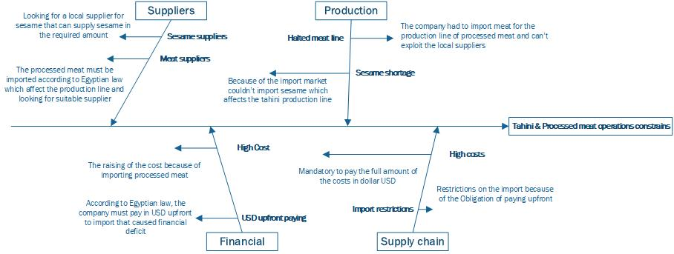

# **SWOT Analysis**

|  |  |
| --- | --- |
| **Strengths** | **Weakness** |
| Strong Reputation.  Consistent quality.  Having an experience in exporting.  Diverse products. | Depending on one category which is agricultural raw materials.  Variable products which increase the operations costs. |
| **Opportunities** | **Threats** |
| Expanding to African countries.  Partnering with agricultural companies to supply the raw materials on long term.  Add new processed product. | Restrictions on the export market.  Instability on the economic on the local market.  Unavailability of the raw materials.  Restrictions on the import market. |

# **Smart Objectives**

## **Goal One**

Helwani Bros will stabilize its product availability and regain customer trust in its processed meat and tahini product lines by the end of the year. The company aims to:

* Reduce product shortages by 50% within the next 6 months by securing alternative suppliers for sesame seeds.
* Maintain a customer satisfaction rate of 90% by ensuring consistent product availability.

**Goal Two**

Helwani Bros will strengthen its supplier network and reduce the impact of import restrictions by:

* Secure at least two alternative suppliers for sesame seeds and imported meats within the next 6 months.
* Reduce dependency on imports by 70% by sourcing locally where possible or using substitute ingredients.

# **OKRs (Objectives and Key Results)**

**Objective 1**

Ensure reliable production and supply of processed meats and tahini.

* Key Result 1: Reduce processed meat product shortages by 50% within 6 months.
* Key Result 2: Secure alternative sesame seed suppliers by Q2 to restart tahini production.
* Key Result 3: Increase production line efficiency by 30% by Q4.

## **Objective 2**

Diversify supplier network and reduce cost pressures.

* Key Result 1: Find at least 2 new locally suppliers for key ingredients within 6 months.
* Key Result 3: Decrease import-related expenses by 15% by optimizing logistics and payment strategies.

|  |  |  |  |  |  |  |
| --- | --- | --- | --- | --- | --- | --- |
| RACI | | | | | | |
|  |  |  |  |  |  |  |
| **Task** | **CEO** | **Operations Manager** | **Procurement Manager** | **Financial Manager** | **Production Team** | **Marketing Team** |
| Identify alternative suppliers | A | R | C | I | I | I |
| Negotiate payment terms | I | A | R | C | I | I |
| Ensure compliance with new laws | I | A | I | I | I | I |
| Manage project budget | I | A | I | R | I | I |
| Maintain production lines | I | R | I | I | R | I |
| Communicate product changes | I | I | I | I | I | R |
| Customer feedback management | I | I | I | I | I | R |
| Monitor supplier performance | I | A | R | I | I | I |

|  |  |  |  |  |  |  |
| --- | --- | --- | --- | --- | --- | --- |
| **Stakeholder** | **Role (Related to Project)** | **Involvement** | **Impact** | **Power (H/M/L)** | **Interest (H/M/L)** | **Engagement** |
| CEO | Project Sponsor | Makes high-level decisions; ensures project success | Project depends on CEO’s approval | H | H | Communicate regularly for updates and decisions |
| Operations Manager | Project Manager | Oversees production; ensures production lines remain active | Directly impacted by supply chain disruptions | H | H | Daily communication to track project progress |
| Procurement Manager | Supplier Sourcing and Purchasing | Responsible for sourcing alternative sesame suppliers and imported meats | Critical to sourcing key ingredients | H | H | Involved in supplier negotiations, frequent updates needed |
| Finance Director | Budget and Financial Planning | Manages budgeting for alternative suppliers and extra costs of import payments | Directly affected by cost increases | H | M | Regular updates on financial impact and cost tracking |
| Production Team | Manufacturing Process | Keeps production lines moving; interested in raw material availability | Moderate impact on daily production routines | M | H | Keep informed about supply changes and production timelines |
| Marketing Team | Product Promotion and Sales Strategy | Communicates product availability to customers | Low direct impact but high interest in product offering | M | H | Keep informed of product line updates, manage communication to customers |
| Warehouse Staff | Storage and Logistics | Handles product storage and delivery | Low impact but affected by supply volumes | L | L | Monitor and provide information as needed |
| Board of Directors | Corporate Governance | Focused on overall business performance | Interested in how the project affects profitability | H | L | Provide regular updates on strategic impact and financial results |
| External Suppliers | External Stakeholders | Provide raw materials (sesame and meat) | High impact as it may be the only supplier and have a negotiation privilege. | H | L | Monitor delivery schedules and contractual obligations |

# **Project Purpose/Justification**

Helwani Bros, a company specializing in food products, is facing significant challenges due to a new law mandating the use of imported meat for processed products and a shortage of sesame seeds, critical for tahini production. The main objectives are to stabilize the supply chain, resume production of halted product lines, and manage cost increases due to import restrictions. The project aims to ensure the company can continue meeting market demands and maintain customer satisfaction.

# **Project Objectives (SMART Goals)**

**Supply Chain Optimization**:

* Secure alternative suppliers for sesame seeds and imported meats within the next 6 months.
* Reduce product shortages by 50% and improve production efficiency by 30%.
* Ensure compliance with the new import laws while minimizing cost increases.

**Production and Financial Management:**

* Resume production of tahini and processed meats by improving sourcing.
* Decrease upfront dollar payment requirements by 20% through renegotiation with suppliers.

**Customer Engagement and Retention:**

* Launch a customer loyalty program within 3 months to retain at least 25% of the customer base affected by product shortages.
* Introduce two new locally sourced products by the end of the year to diversify product offerings.

# **Key Deliverables**

* Alternative supplier contracts for sesame and meat.
* Improved financial payment systems to reduce upfront costs.
* Relaunch of product lines (tahini, processed meats) with new sourcing.
* A customer loyalty program to maintain and grow the customer base.
* Introduction of locally sourced product alternatives to expand offerings.

# **Project Scope**

* This project includes securing alternative suppliers, adjusting production lines, and improving financial terms with suppliers.
* Focus will be on relaunching halted product lines and introducing new products.
* The project excludes expanding production to additional product categories not related to sesame or meat.

# **Milestones**

* Month 1-2: Identify alternative suppliers for sesame and meat.
* Month 3: Launch customer loyalty program.
* Month 4-5: Resume tahini and meat production.
* Month 6: Introduce two new locally sourced products.

# **Budget**

Projected Costs:

* To be determined based on supplier renegotiations and production adjustments.

# **Risks**

* Supply chain delays due to global shipping constraints.
* Rising costs due to currency fluctuations and import restrictions.
* Customer dissatisfaction if production delays persist.

# **Risk Mitigation**

* Diversifying the supplier network to reduce dependency on specific regions.
* Maintaining transparent communication with customers regarding product availability.
* Implementing cost-saving measures in production to offset increased import costs.

# **Project Team**

* CEO (Sponsor)
* Operations Manager (Project Manager)
* Procurement Manager
* Finance Director
* Marketing and Sales Team
* Production Team